**BIKENET.RO**

**Test report**

**Tester name:** Ioana Adela Borbely

**Testing period:** 25-27.03.2020

1. **Status of the system under test:**

**Number of bugs found:[20]**

**Most important bugs:**

|  |  |  |
| --- | --- | --- |
| **Type** | **ID MANTIS** | **DESCRIPTION** |
| Registration | 0025247 | First and last name fields accept numbers. |
| Registration | 0025251 | Empty spaces input in name and last name fields. |
| Registration | 0025250 | Accepts city and district even if they don’t match. |
| Wish list | 0025258 | Does not display a total amount. |
| Shopping bag | 0025262 | You can type string text in the quantity field. |
| Shopping bag | 0025264 | Negative input is allowed. |
| Shopping bag | 0025265 | The item can be added when the product is out of stock. |
| Main menu | 0025277 | Using the main menu. |
| Main menu | 0025279 | “Cumpara produsul” option is not working. |
| Main menu | 0025280 | Newsletter e-mail confirmation not received. |
| Account | 0025266 | Changing the password with the same password. |

**List to all the bugs can be found at:**

<https://bugs.scoalainformala.ro/view_all_bug_page.php?page_number=1>

**Test case execution status:**

* Number of test cases run: **44**
* Number of test cases **Failed** vs **Passed**

**Failed test cases:**

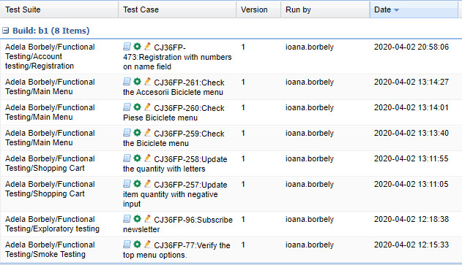

**Performance test status:**

Performance test was run using **50 threads**.

There were a total of 6.80% errors, the average response time is not high, but we can see that the most important features have the highest error percentage response time: Registration, Main menu with 8% and Home category page with 10%.

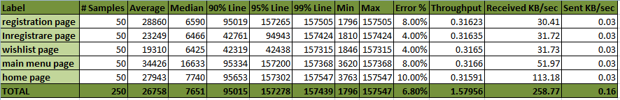

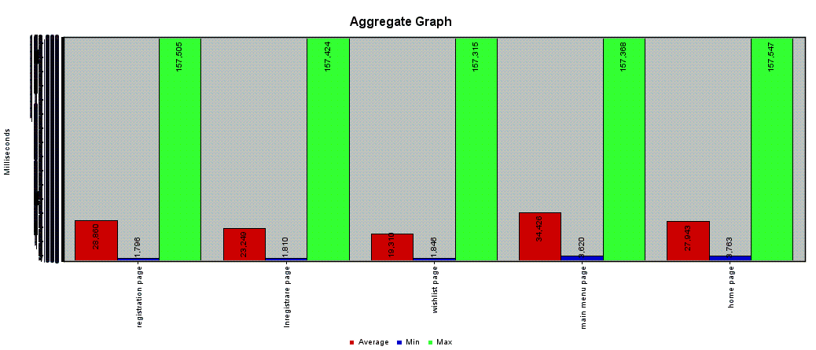

1. **Strategy:**

**Approach**

During the testing period the following testing activities were performed, in the given order:

* Creation of functional test cases. The test suite contains a subset of test cases which can be run as a smoke test.
* Execution of functional test cases & logging of defects.
* Exploratory testing.
* Non-functional testing.
* Performing testing.

**Platforms**

* OS: Microsoft Windows 10 (1909 version), Android version 9.
* Browsers: Google Chrome, Opera, Microsoft Edge

**Tools**

* TestLink
* Mantis (bug tracking)
* Jmeter
* Excel

1. **Covered functionality:**

* Registration functionality
* Login functionality
* Account functionality
* Password recovery functionality
* Shopping bag functionality
* Wish list functionality
* Search functionality
* Home page functionality

1. **Conclusion:**

Smoke test cases for main functionalities in a percent of 100% were executed, 5 test cases were passed, 1 failed. The failed test case is related to top menu option.

In addition to Smoke and Positive testing, testing types such as: Functional Testing, Exploratory Testing, Compatibility Testing, Negative Testing, Integration Testing, were covered.

Most of the bugs found were identified by performing Negative testing and Positive Testing.

Compatibility testing was performed from different browsers and devices.

Performance testing via Jmeter application resulted smaller page loading for the existing category.

During the testing process, a few issues were found in the following areas:

* Registration
* Wish list
* Shopping Bag
* Main Menu

Overall the product is stable and shippable, but the defects that were found may affect the client’s / users confidence and trust of the overall image of the company.

My recommendation would be to fix the bugs listed, especially in the users account area, main menu, payments and registration. The product can be released and the existing bugs needs to be fixed as soon as possible so the company won’t lose clients trust.